Lab Sheet 4

Report

Q2.

Below are some of the values observed in the output to give an idea:

x0 x1 Value of Root

_____ _____ _____________

1.95 2.05 2

1.951 2.05 NaN

1.95 2.049 1.9929

1.951 2.049 NaN

1.952 2.049 NaN

1.951 2.048 2.048

1.997 2.003 2

1.998 2.003 1.9981

1.997 2.002 1.9998

1.998 2.002 2

1.999 2.002 NaN

1.998 2.001 NaN

1.999 2.001 2

2 2.001 2.001

1.999 2 1.9993

* I returned NaN from my bisect function whenever f(x0) and f(x1) are of the same size. Even though in all these cases x0<=2 and x1>=2, making f(x0) and f(x1) to be of different sign, we still get a lot of NaN values for the root.
* We get wrong answers even at very low tolerance values.

Q3.

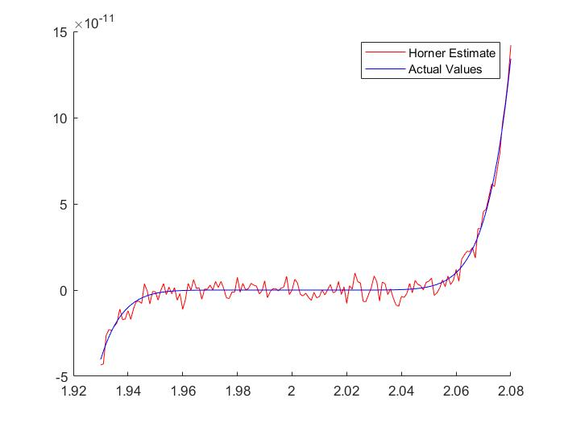

* The plots differ from one another. The plot using Horner's rule has a lot of noise.
* When we use Horner's rule, we have to deal with large coefficients and many addition and subtraction operations between these numbers causing rounding errors.
* Since the values of function at root is zero, these values being computed are small and prone to errors due to catastrophic cancelling.
* We see that the actual curve is largely flat around x=2, this causes the noisy Horner estimate to cross y=0 many times, which is the reason for the various NaN values observed in Q2.
* As a result of all these factors, we get wrong answers in Q2.